Q3)

1. Simulate the circuit for Ls=0, Van, Vbn and Vcn are balanced three phase voltages connected to the same grid as before, diodes are ideal and Id=30 A. Plot the output voltage and phase A input current on the same graph.

Figure 1: Three Phase Full Wave Rectifier Circuit Diagram in Simulink

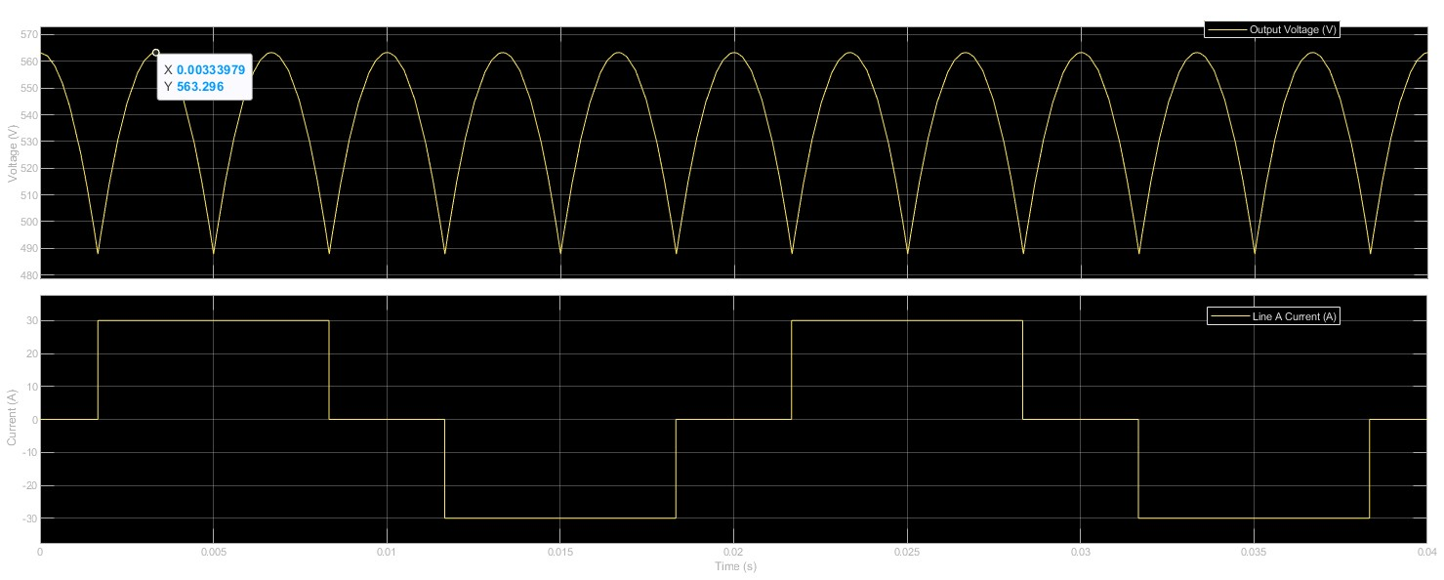

Figure 2: Output Voltage, Input Line Current vs Time

1. Analytically, calculate the output voltage average and compare with simulation results. Comment on any differences.

For three phase rectifier, the average output voltage Vavg calculated as follows:

$$V_{avg}=\frac{3\sqrt{6}}{π}V_{p_{rms}}=1.35V_{l-l}$$

$$where V_{l-l}=400V for the Turkey AC Grid$$

So that;

$$V_{avg}=\frac{3\sqrt{6}}{π}V_{p_{rms}}=1.35V_{l-l}=1.35*400=540 V$$

Then calculate the output average voltage of the our circuit,

$$V_{peak}=563. 296 V$$

$$V_{rms}=\frac{V_{peak}}{\sqrt{2}}=\frac{563.296}{\sqrt{2}}=398.310 V$$

$$V_{avg}=1.35*398.310 V=537.719 V$$

The error $$ε=\frac{ V_{avg_{calculated}}-V_{avg_{actual}}}{V_{avg_{calculated}}}*100=\frac{540-537.719}{540}*100=\%0.422$$

The main reason of the difference between the actual and calculated value is that the Simulink does not work with the zero forward bias voltages so that the choice to set the diode's forward bias voltage to **1e-6 V** in Simulink to approximate ideal diode behavior is a reasonable approach, but it can still introduce small discrepancies in the output voltage. Although setting the forward bias voltage to **1e-6 V** approximates an ideal diode, it is not zero. This small non-zero forward voltage drop means that when the diode conducts, it will still have a slight voltage drop, which reduces the output voltage compared to the ideal case where the drop is zero. Setting the diode forward voltage to a small non-zero value is a common practice to avoid simulation errors, but it can lead to slight discrepancies in the output voltage due to the reasons mentioned above.